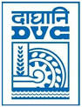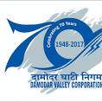
DAMODAR VALLEY CORPORATION
INFORMATION & PR SECTION
SECRETARIAT DEPARTMENT
DVC TOWERS : VIP ROAD
KOLKATA - 700054

PRESS RELEASE

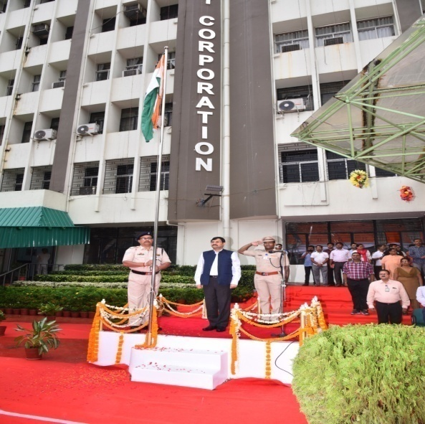

DVC celebrated “The 73rd Independence Day”
The 73rd Independence Day was celebrated by Damodar Valley Corporation (DVC) on 15th August 2019 across the Valley.
At DVC Hqs., Kolkata, Dr. P.K. Mukhopadhyay, Member-Secretary, DVC hoisted the National Tri-Colour and took salute of CISF contingent followed by soulful rendition of the National Anthem. A prize distribution session was organized to honour the employees of DVC and CISF for their admirable performance in discharging official duties.
The programme concluded with the demonstration of Silent Drill, Terrorist Hostages Rescue, Checking and Frisking Duty etc. by CISF personnel.
Member (Technical), Member (Finance), Chief Vigilance Officer, Executive Directors, DVC High Officials and a large number of DVC and CISF employees were present on this occasion.

