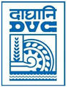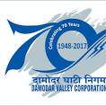
DAMODAR VALLEY CORPORATION
INFORMATION & PR SECTION
SECRETARIAT DEPARTMENT
DVC TOWERS : VIP ROAD:KOLKATA - 700054
PRESS RELEASE

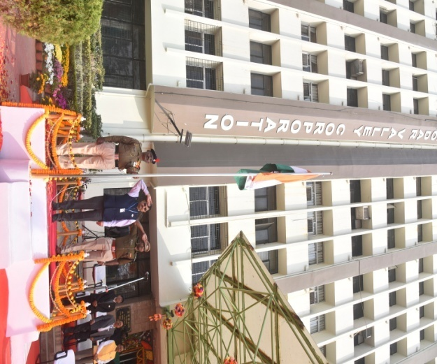
DVC celebrates Republic Day
The 71st Republic Day was celebrated by Damodar Valley Corporation (DVC) on 26th January 2020 across the Valley.
To mark the day at DVC Hqs. Kolkata, Dr. P.K. Mukhopadhyay, Member-Secretary, DVC unfurled the National Tri-Colour and took salute of CISF contingent followed by soulful rendition of the National Anthem.
A prize distribution session was organized to honour the employees of DVC and CISF for their admirable performance in discharging official duties.
The programme concluded with the wonderful demonstration of weapon handling, VIP security, checking and frisking duty etc. by CISF personnel.
Member (Finance), Chief Vigilance Officer, Additional Secretary, Executive Directors, DVC High Officials and a large number of DVC and CISF employees were present on this occasion.

