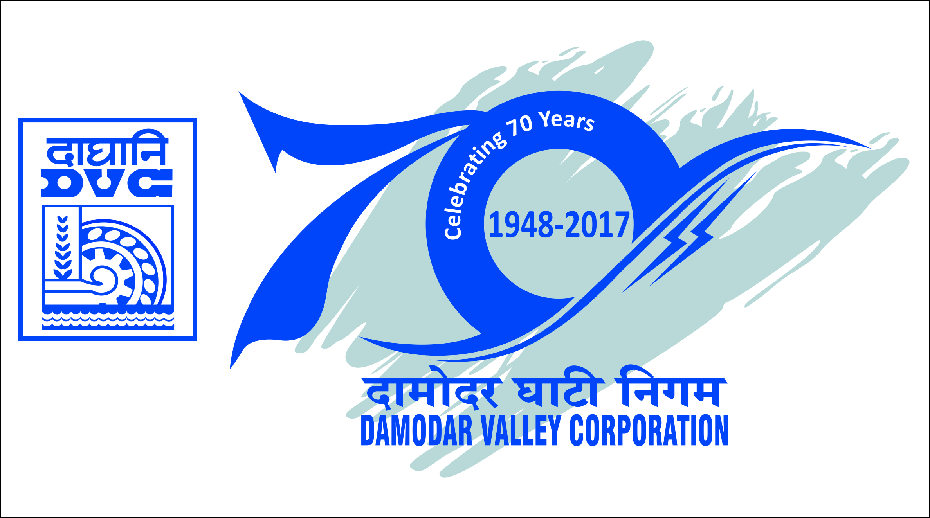

दामोदर घाटी निगम/Damodar Valley Corporation
सचिवालय विभाग/Secretariat Department
डीवीसी टावर्स/DVC Towers : वीआईपी रोड/VIP Road
कोलकाता/Kolkata-700054

PRESS RELEASE

Damodar Valley Corporation (DVC) organised a webinar on “Innovative ways of Fly Ash Utilisation”

Damodar Valley Corporation (DVC) in association with National Productivity Council (NPC) organised a webinar on “Innovative ways of Fly Ash Utilisation” on PAN INDIA level on 10.07.2020.
The webinar was formally inaugurated by Shri Gurdeep Singh, Chairman, DVC.
Various technical presentations on innovative uses of Fly Ash were given by different experts namely, Shri Rakesh Ranjan, DVC, Shri Tapas Kumar Gupta, Chief Engineer, WBPCB, Shri N. Kalidas and Dr. S. V. Patankar.

A total of 345 participants including representatives from various Cement Companies like Ultra Tech Ltd, ACC, Birla Corporation Limited, Nuvoco Vistas, Corp Ltd, Shree Cement, Dalmia, etc., ash traders/exporters, consultants and researchers, academicians from IITs, Power sectors like NTPC, DVC, NLC, BHEL, CIL Adani Power, Lanco-infra, State Power Generators participated in the webinar.

This interactive Webinar helped to learn about the various ways for maximizing the fly ash utilization.

****

