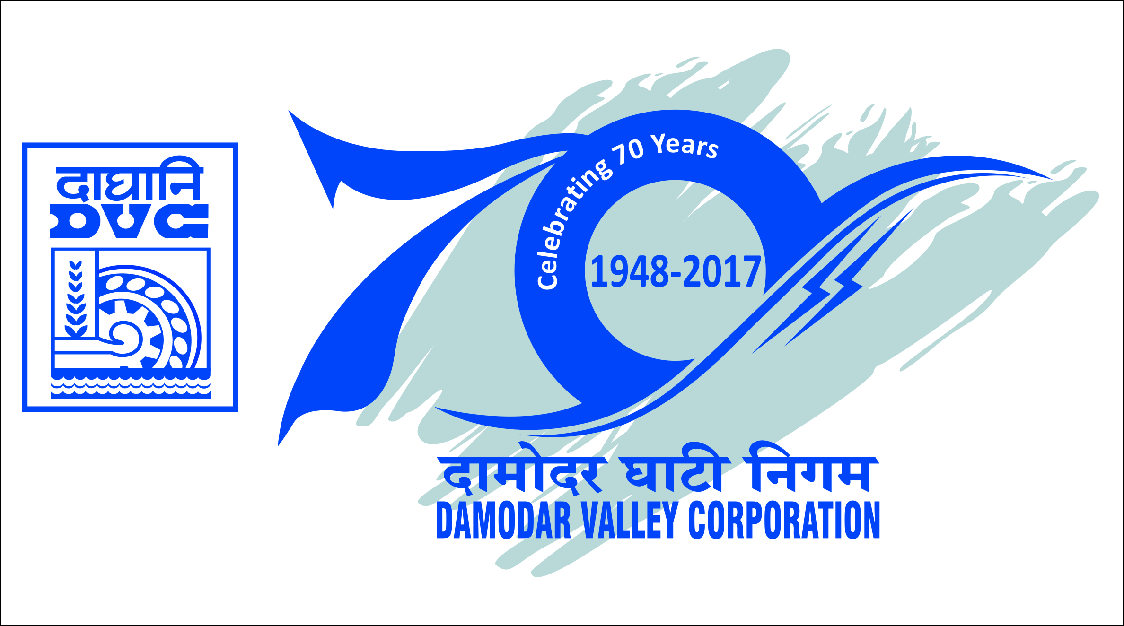
दामोदरघाटीनिगम/Damodar Valley Corporation
सचिवालयविभाग/Secretariat Department
डीवीसीटावर्स/DVC Towers: वीआईपीरोड/VIP Road
कोलकाता/Kolkata-700054

PRESS RELEASE

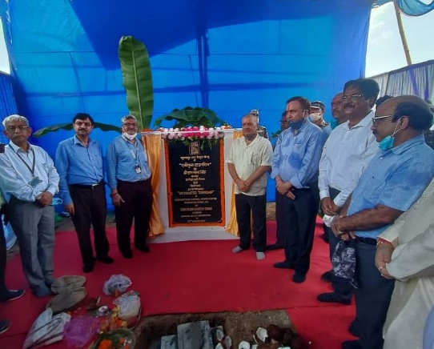

Chairman DVC laid Foundation Stone of “Integrated Township” at Raghunathpur Thermal Power Station.

Chairman of Damodar Valley Corporation Shri Ram Naresh Singh laid the foundation stone of “Integrated Township” at Raghunathpur Thermal Power Station (RTPS) on 22.08.2021.
Member-Secretary, Dr.P.K. Mukhopadhyay,Member (Technical), Shri M. Raghu Ram, Chief Vigilance Officer, Shri Shankar Lal Bhalotia, Executive Directors, Chief Engineer & Project Head and Chief Engineer & Head (O&M) of Raghunathpur Thermal Power Station (RTPS) were also present to mark the occasion.
The work of construction of “Integrated Township” at Raghunathpur Thermal Power Station (RTPS) has been awarded to M/s Cognition Projects Private Limited.
Chairman, Damodar Valley Corporation in his addressto the employees and their family members stated that the project shall be constructed within 18 months.
The “Integrated Township” includes 96 nos. of accommodations each for executives and non-executives, a Bunglow for Chief Engineer & Project Head, a Primary School, aHospital, a Community Centre and an Overhead Reservoir.

