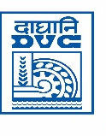
दामोदर घाटी निगम/DAMODAR VALLEY CORPORATION
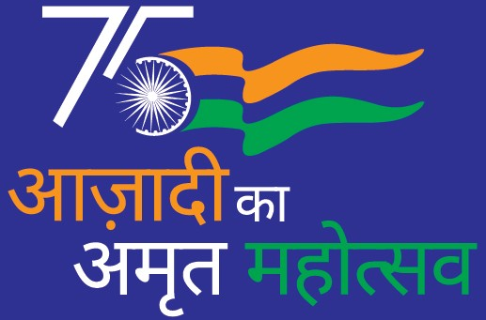
सूचना व जनसम्पर्क विभाग/Information & PR Section
डीवीसी टावर्स/DVC TOWERS :: वीआईपी रोड/VIP ROAD
कोलकाता/KOLKATA – 700054
Phone/फोन : (033) 6607 2128 :: e_mail/ई_मेल : cpro@dvc.gov.in

PRESS RELEASE

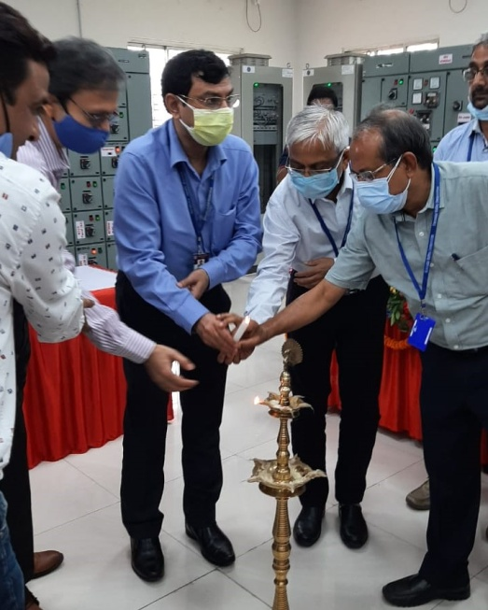

DVC organized Power Supply Connection Mela
DVC organized Power Supply Connection Mela for new consumers at Barhi Sub-Station on 17.08.2021 and Ramgarh Sub-Station on 18.08.2021.
The purpose for organizing such event was to reach to the prospective consumers in and around DVC Substations and assess the potential load growth to expand the distribution business within DVC’s area of operation.
It received a very positive response from the prospective consumers who interacted with DVC executives and got their queries clarified.
Prospective consumers requested DVC to extend its power supply to various industrial areas where many industries are interested to avail of DVC power for better business growth.
Member-Secretary, Executive Director (Commercial), Head of DVC Maithon Project and senior executives of DVC were present during the event.
Member-Secretary, DVC in his address assured the prospective consumers to arrange power supply for the interested consumers in a time-bound manner.
ED (Commercial) informed that similar events will be held at other DVC Substations in the states of Jharkhand and West Bengal for overall growth of industries in the Damodar Valley area.
DVC is also planning to set up distribution stations at various emerging load centers to make DVC power available to all prospective consumers.

*****

